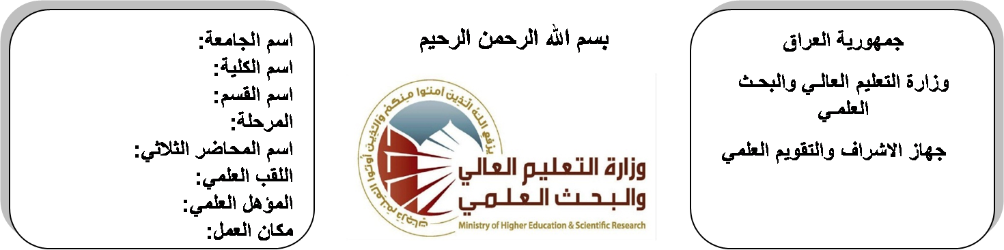

**Republic of Iraq**

**Ministry of Higher Education**

**& Scientific Research**

**University: Diyala University**

**College: College of Engineering**

**Department: Electronic Engineering**

**Stage:3 rd stage**

**Lecturer name: ayad qays**

**Qualification: Msc**

**Place of work: Electronic Dept.**

**(( Annual teaching plan form))**

|  |  |  |  |  |
| --- | --- | --- | --- | --- |
| **Lecturer Name** | **Ayad qays abdulareem** | | | |
| **Email** | **Aiyad_qais@yahoo.com** | | | |
| **Subject** | Antenna & Propagation | | | |
| **Aims** | **The aim of this subject is to make the students ready to undestand and comprehend the scientific theories and their applications related to their field of the study.** | | | |
| **Textbooks** | **ANTENNA THEORY AND DESIGN BY STUTZM** | | | |
| **Additional Textbooks** | **ANTENNA BY KRAUS** | | | |
| **Assessments** | **First Semester** | **Second Semester** | **Laboratory** | **Final Exam** |
| 20 % | 20 % | 10 % | 50 % |
| **Notes** |  | | | |

**Schedule Weekly Lessons - First Semester**

|  |  |  |  |  |
| --- | --- | --- | --- | --- |
| **Week** | **Date** | **Lectures** | **Lab. Experments** | **Notes** |
| 1 | **30/9** | Isotrop & point radiator with reflector & parttern |  |  |
| 2 | **7/10** | The hertizian dipole& its pattern of electric field & power density Short antenna |  |  |
| 3 | **14/10** | Gain &short ant, Directivity & beam width |  |  |
| 4 | **21/10** | Antenna & its pattern of field &radiation resistance & polarization. |  |  |
| 5 | **28/10** | The loop antenna & Its field |  |  |
| 6 | **4/11** | Radiation, resistance & pattern receiving antenna & effective area of antenna Radar equations & path losses |  |  |
| 7 | **11/11** | Antenna above ground & monopole, Pattern |  |  |
| 8 | **18/11** | Folded antenna, Point radiator arrays &multi antenna arrays & their gain &patterns stacked antenna Yagi antenna Slot antenna |  |  |
| 9 | **25/11** | Microwave antenna |  |  |
| 10 | **2/12** | Microwave antenna |  |  |
| 11 | **9/12** | Horn &parabola |  |  |
| 12 | **16/12** | Horn &parabola |  |  |
| 13 | **23/12** | Helical antenna& helix& ionosphere & wave, Propagation &type of waves |  |  |
| 14 | **30/12** | Time varying field & Maxwell's equation, Faradays law |  |  |
| 15 | **6/1** | Amperes law, Gauss's law, Boundary condition on the field vectors |  |  |
| 16 | **13/1** | Amperes law, Gauss's law, Boundary condition on the field vectors |  |  |
| Half Year holiday | 15/1 to  1/2 |  |  |  |

**Lecturer Signature Head of Dept. Signature Dean Signature**

**Schedule Weekly Lessons - Second Semester**

|  |  |  |  |  |
| --- | --- | --- | --- | --- |
| **Week** | **Date** | **Lectures** | **Lab. Experments** | **Notes** |
| 1 | **17/2** | Time-Instantaneous Pointing Theorem |  |  |
| 2 | **24/2** | Time-Instantaneous Pointing Theorem |  |  |
| 3 | **2/3** | Plane Wave Complex Pointing Vector |  |  |
| 4 | **9/3** | Plane Wave Complex Pointing Vector |  |  |
| 5 | **16/3** | Planes wave & their characteristic in free space |  |  |
| 6 | **23/3** | The wave equation |  |  |
| 7 | **30/3** | uniform plane wave |  |  |
| 8 | **6/4** | Propagation of plane wave in losses media |  |  |
| 9 | **13/4** | Polarization of uniform plane wave |  |  |
| 10 | **20/4** | Normal incident of uniform plane wave on plane boundaries |  |  |
| 11 | **27/4** | Guided waves |  |  |
| 12 | **4/5** | Wave between parallel planes |  |  |
| 13 | **11/5** | Wave between parallel planes |  |  |
| 14 | **19/5** | Transverse electric wave (TL-wave), Characteristic of TE&TM waves. |  |  |
| 15 | **26/5** | Transverse Electromagnetic Wave (TEM-waves) & Waves Guides |  |  |
| 16 | **3/6** | Transverse Electromagnetic Wave (TEM-waves) & Waves Guides |  |  |
| Half Year holiday | 15/1 to  1/2 |  |  |  |

**Lecturer Signature Head of Dept. Signature Dean Signature**